South West Gospel Partnership

Ministry Training Course Taster Day

Thursday, 12th March 2020
9.45am – 2.15pm

St. Bartholomew’s Church, 1 King Edward Road,

Oldfield Park, Bath, BA2 3PB

The South West Gospel Partnership (SWGP) Ministry Training Course is a one-day-a-week course for those who want to understand the Bible better and be equipped to teach it to others. We would like to invite you to our Open Day to find out how the course could benefit you and others in your church.

Programme

9.45am Welcome and Coffee
10.00am Daniel (Bible Overview), Speaker: Charlie Ward
11.05am Coffee
11.20am Exodus (Part 3 of 5), Speaker: Spencer Shaw
12.30pm Lunch with Presentation and Question Time
1.15pm Postmodernism, Speaker: Ian Lewis

If you are unable to attend the whole day, you are welcome to join us just for the lunch and presentation.

How to find us: St.Bartholomew’s Church is situated in central Oldfield Park, to the south of the city centre.

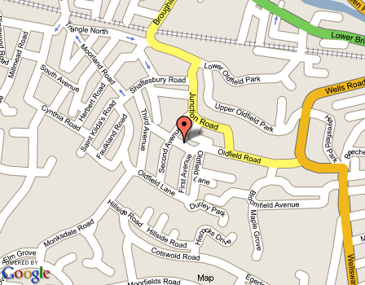

Parking: Parking outside the church is limited, so you may need to find a space in the residential streets close by.

Station: Oldfield Park (10mins), Bath Spa (20mins walk)

If you wish to attend the Taster Day, please complete the booking form below and return by 5th March to: Jane Clark, SWGP Administrator, c/o St. Bartholomew’s Church, 1 King Edward Road, Oldfield Park, Bath BA2 3PB, or email jane@swgp.org.uk
------------------------------------------------------------------

SWGP MTC Taster Day Booking Form
Name:……………………………………………………………………
Address:…………………………………………………...………………………………………………………………………………………….
Tel:………………………….Email:………………………………….....................................................................................................
Home Church:....................................

I should like to stay for lunch □

Please state any dietary requirements……………………….

Signature…………………….…Date………………………………

